A000-Eur-Danubian Rider Cult-Plaque-Semi-circular Architrave-Solomonic Spiral Columns-Lotus Capital-Lead-1-3 c CE no.2

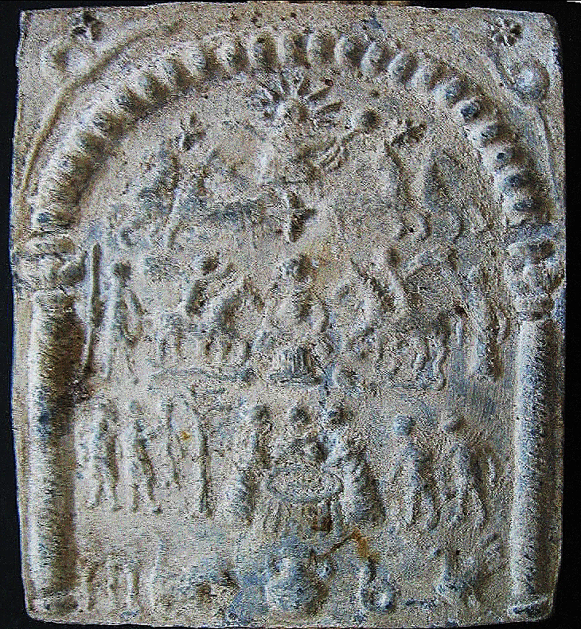

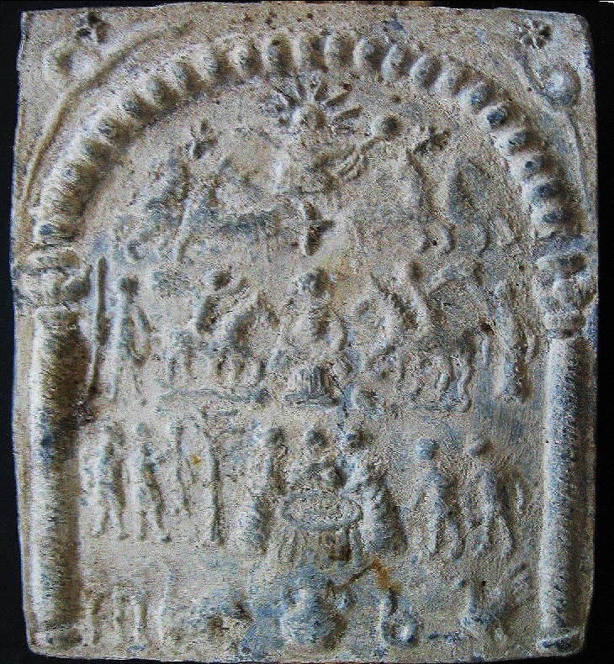

Figs 1-2. Eur-Danubian Rider Cult-Plaque-Semi-circular Architrave-Solomonic Spiral Columns-Lead-1-3 c CE

**Case no.: 4**

**Accession Number:**

**Formal Label:** Eur-Danubian Rider Cult-Plaque-Semi-circular Architrave-Solomonic Spiral Columns-Lead-1-3 c CE

**Display Description:**

The Danubian Rider Cult was developed by Dacians and their allies (Dalmatians, Moesians, Sarmatians and Thracians) in the first three centuries CE by combining two equestrian cults, Epona and the Thracian Rider.

Epona, the Gallo-Roman equestrian protectress and psychopomp escorts newly deceased souls from Earth to the Afterlife and has parallels in insular Celtic cults such as Rhiannon of the Welsh epic, *Mabinogion*. The Thracian Rider was also a psychopomp who escorts newly deceased souls from Earth to the Afterlife. He is usually shown charging (with a spiritual helper like a dog, boar or lion beneath his steed) to the right towards an image of the newly deceased’s stela, tree of life or statue. The Thracian Rider cult is known from 4th century Greek and Latin inscriptions that describe him as "the hero" (*o ἥρως*, o hḗrōs), which is linked to the Thracian term for "the hero," o *ierus, or o *iarus. The demonstrative article “o” is important for its suggests an importance that elevates his epithet. Hence, the Thracian Rider as *o ἥρως* was a divinity on the same level as the Greek mythic *o ἥρως* (Detschew 1957: 200).

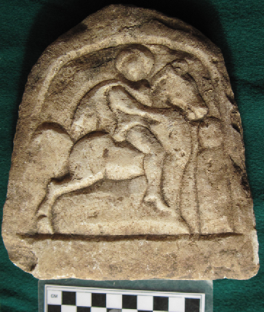

Thracian Rider Plaque from Odessos-Marble-4th century BCE. The rider as a divine psychopomp with a halo signifying his divinity, is approaching a newly deceased wrapped in linen shrouds, who is about to be carried away to the Hereafter.

The imagery of this lead plaque is divided into four registers. At the top, register 1, is an image of the Epona with her himation gown clasped by a circular fibula to the left. She peers out beneath the vault of the Heavens. She is flanked by two serpent-dragons (symbols of the Delphic Apollo) speaking their oracular knowledge to her. The serpent-dragon was an important iconic aspect of Dacian symbolism, as evidenced by their legendary ‘Draco’ banners as depicted on Trajan’s column in Rome. Register two features the Thracian Rider, the figure to the left, charging to the right on his steed. **To the right is the horse of Epona above a fish, a symbol of mystical, sacred food that signifies the horse having eaten of the fish is now transubstantial with Epona.** Both figures converge on the standing, long-haired figure of Epona in the center dressed in a linen chiton gown covered by a heavier short himation cloak. The third register shows the Thracian Rider and Epona leading the newly deceased to the Afterlife with marshals both before and after the group holding their staves of authority and protection. **The fourth register shows a mystical fish on a tripod to the left and, in the center, an altar which is where the believers will partake of the fish and thus become transubstantial with the deities. To the right is Epona’s horse. This register probably offered the most serious challenge to the early church because it fixated on the Danubian symbolism of the fish as the mystical food of communion with the deities, Epona and the Thracian rider. In the clandestine church of the first three centuries the fish, in Greek ΙΧΘΥΣ (ichthys), or ΙΧΘΥϹ, was an acronym for "Ἰησοῦς Χριστός, Θεοῦ Υἱός, Σωτήρ, 'Jesus Christ, Son of God, Savior'. Although the Danubian mystical fish communion had developed independently from the early church, it employed the eating of the fish as the eating of their Saviors in their eucharist.**

**This type of cult production is typical of the provinces bordering the Danube (Pannonia and Dacia) in the third and early fourth century AD.**

**The entire decoration of these plates is framed by an ornate arch resting on two Corinthian columns. This is probably the simple representation of a temple of the Sun. Above, and in each corner of the plate, serpents crawl while winding.**

**At the level of the "tympanum" of this stylized sanctuary, the space is entirely occupied by the representation of the solar quadriga seen from the front as on the ribbed coins of the Emperor Probus (276-282)**

**The two stars that frame the Sun emphasize the eternity of its power and its action in the course of time.**

**In the center, a goddess dressed in the chiton and the himation is framed by riders, local gods of the type "Dioscures"? On the left, the first trots on a fish placed horizontally; on the right, the second does the same on a man lying on the ground. Near the rider on the left stands a soldier; near the rider on the right, a draped woman (Victory?).**

**Below, in the center, a group of priests is sitting near a table. On the right, a couple of young men come to the table; on the left, a ram is going to be sacrificed.**

**At the bottom, four figures (a tripod table with a fish, a lion, a snake and a rooster) probably symbolize the four primordial elements: water, fire, earth and air.**

**LC Classification:** DF261.T6

**Date or Time Horizon:** 4th c CE

**Geographical Area:** Danubian River valley

**Map:**

**GPS coordinates:**

**Cultural Affiliation:** Dacians and their allies (Dalmatians, Moesians, Sarmatians and Thracians)

**Medium:** Lead

**Dimensions:**

**Weight:**

**Condition: original**

**Provenance:** Serian collection

**Discussion:**

Within the territory of the so called Danubian provinces of the Roman Empire – Dacia, Moesia and Pannonia – there can be found a large number of archaeological artifacts belonging to a syncretistic or mystical cult. On the one hand, the monuments of this cult were found largely in the mentioned provinces and in lesser numbers in Dalmatia (12 pcs.), Noricum (1 pc.) and Thracia (2 pcs.). On the other hand, the results of the most recent research claim that apart from the Pannonia region, the frequency of the finds is higher in Upper Moesia, especially in the areas of Singidunum and Viminacium. See: Поповић 1992; Tudor 1976, 52; Зотовић 2001. These are mostly stone reliefs and small lead plaques without almost any trace of epigraphic evidence or votive inscriptions that could reveal more information about the deities in question, including their names. This, as well as the fact that for most of those artifacts we have no knowledge about the context of the finds, hampered attempts to understand their very complex iconographic and theological content that has intrigued many researchers since the second half of 19th century (Tudor 1976, 49-51). The main element of this complex cult, since among various iconographic versions of these monuments it appears as a constant, is the representation of the cult’s central figures, showing one or two horsemen approaching a goddess. Considering the portraits of these horsemen, whom some of the relevant authorities denote as Cabiri (Dioscuri)2 or Thraco-Mithraic riders (Мladenova 1984; 1958), the cult was finally named the “Danubian horsemen’’. (1889) compiled a corpus of the monuments of the cult, which had been discovered by his time, linking them to the Cabiri. At a later stage E. Nowotny (1896, 206) accepted this reasoning stating that it was a question of either Cabiri or Dioscuri. Some critical review of this interpretation was given in more recent literature by M. Tatcheva (2000). This was based on D. Tudor’s belief that the cult had a local character within the territories of the middle and lower Danube basin, originating in the province of Dacia3 Tudor (1976, 50, 94) based his opinion on the frequency of the finds of the monuments he classified as Class A, images that showed only one horseman with the goddess and were created according to the iconographic patterns of the Thracian horseman, which he considered to be chronologically the oldest. They were found in their largest numbers in the Roman province of Dacia Opposing his view was an interpretation claiming that the central deity of this cult was a goddess while the horsemen were her subjects. According to that opinion, since her character could be seen as resulting from solar theology, the name of the cult could be changed to the Cult of the Lunar Goddess Lj. Zotović in 1975 for the first time expressed her opinion that the goddess could be a solar deity, Luna, a central figure of the cult in which the horsemen were subordinate to her. At a later stage she developed this hypothesis, suggesting that the new religion was created under the influence of Mithraism, i.e. as an expression of the same solar theology. Since in Mithraism women were not allowed to participate in mystery rites, the new religion with a central female deity was to attract, among others, many women as devotees in the eastern provinces of the Empire, thereby becoming a counterpart to the growing religion of Christianity (Зотовић 2001, 176-177; 1998; 1978; 1975, 41). Epona (and Celtic fertility goddesses, in general) whose influence can be found in the monuments that, according to Tudor’s typology (1976, 94), belong to Class B, showing a goddess surrounded by two horsemen. Actually, this idea had been emphasized by some earlier researchers but abandoned at a later stage or treated just as one of the possible analogies in the goddesses’ image, expressing its predominantly syncretistic character. We, however, believe that its presence was not of an accidental nature but occurred as a consequence of the natural evolution of the cult that has accordingly assumed specific iconography.

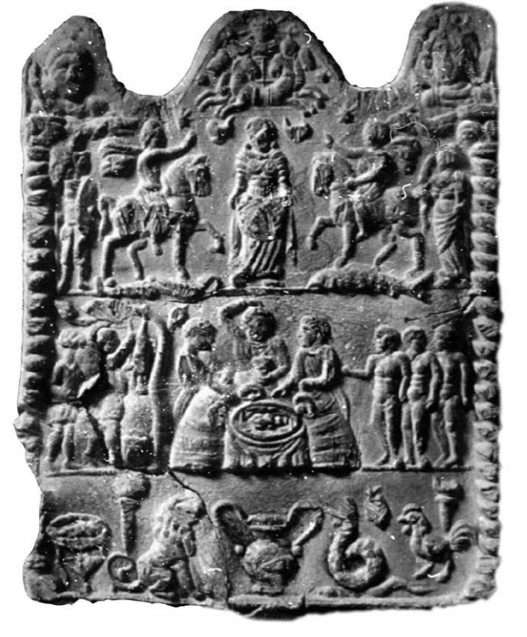

Lead icon of the Danubian horsemen; Belgrade City Museum, Belgrade

In all the monuments of the Danubian horsemen, the goddess herself seems quite modest, has no specific attributes or clothes. She is mainly wearing a knee-length dress (chiton) with a shorter dress on top (himation) and a fitting belt. On her head there is sometimes a modius or a veil5 , with her long hair floating down the shoulders. Interpretations of her image have a wide syncretistic range, from Artemis – Anahita – Cybele – Rhea – Venus – Diana of Ephesus (Antonescu 1889, 37, 45) to Nemesis – Asa – Spandarmat – Artemis – Agathe Tyche (Campbell 1968, 234). Likewise, some have claimed that she is a representation of the general fertility goddess of the Magna (Terra) Mater type, assimilated with Demeter, Epona and Helen (Tudor 1976, 106), highlighting the aspect of this goddess related to the soil and water that gives life (aquae vitae) while reigning over the sublunar world under the protection of the goddess Luna (Ochsenschlager 1971, 59-60).

There is an interesting interpretation that treats one of the symbols with special emphasis, namely the symbol of the fish that was considered as the main attribute of the goddess. This interpretation draws its origin from the Syrian goddess Atargatis, whose cult regarded fish as a sacred animal. Fish was prohibited for human consumption except on occasions following the sacrificial rites when it was allowed only for the priests. It was understood that the presence of the fish on the tripod or on the banqueting table of the Danubian plaques was intended solely for the horsemen, who would, having consumed this mystical food, become consubstantial with the goddess (Tudor 1976, 104-106). The impact of the Syrian goddesses was also accepted by Lj. Zotović (1998, 75), although she believed that, since such monuments were not found in the territories in which the cult existed, the cult itself had primarily been spread by priestesses of an oriental origin who conceptualized the role of a woman in a consecration rite and thus introduced fish as an attribute, a sacred food of the gods and mystai. However, Tudor, as one of the most significant researchers of the Danubian cult, rejected all of these and made a final conclusion that the deity in question showed no specific characteristics that would allow its identification as any of the known goddesses or indicate her name. According to him, this goddess had a universal character of Magna Mater, with numerous attributes whose number increased as it came into contact with other religions, which was typical in the times of emphasized syncretism (Tudor 1976, 281).

The mere presence of the fish in the icons of this cult was one of the main arguments against identifying the goddess as Epona. J. Hampel was the first one to insist on this since he considered it obvious in all of the representations where the goddess is shown touching the muzzles of horses or feeding them. However, following a harsh criticism claiming that fish was an unknown attribute in Epona’s cult, he abandoned his initial theory (Tudor 1976, 104). Later, there were a few sporadic cases mentioning this influence, among many others, in the assimilated image of the syncretistic goddess. Finally, Tudor (1976, 142-144) concluded that it could not be denied that the goddess had some of the attributes of Epona, but that did not mean that she could be fully identified with Epona, since fish as a symbol, to start with, was not her attribute at all. Also, he pointed out that the goddess was never shown as Epona typically is, mounted on a horse, holding a patera and cornucopia or a circular vase overflowing with offerings. He admitted, though, that the cult of Epona could have spread through the military camps in the Lower Danube basin, starting with the period of Celtic invasion, when it entered the military pantheon primarily due to soldiers in riding units who respected her along with other deities. The complete absence of Epona’s image in Dacia, i.e. the image of this deity surrounded by horses, as well as the rare appearance of her image in the territories south of the Danube, in his opinion, constituted a valid argument against these two groups of reliefs being in any iconographic contact whatsoever. Having in mind more recent data on the number and spatial distribution of registered monuments of the Danubian horsemen and the corpus of recorded artistic images of Epona (Boucher 1990; Euskirchen 1993), it is our intention here to re-emphasize the undisputable existence of Celtic influence on the iconography of the goddess in certain Class B icons. The impact of this influence can be found, as already noted, in the movement of the goddess reaching out her hand to touch the horses’ muzzle or feeding them, as well as in the representations where she lifts the skirts of her robe to make a sort of pouch offering the horse fodder, and in rare images where she is shown enthroned. Consequently, we shall first focus on some rather contradictory facts we believe exist in the previous interpretations.

Although fish was not known as a symbol in Epona’s cult (Boucher 1990, 996-999), its influence is actually reflected in an already partially formed image of the Danubian goddess, which initially incorporated the aforementioned attribute. To confirm this, we find fish in some of the oldest Class A monuments from Dacia, which show the goddess with a single horseman but cannot be linked to the iconography of Epona (Tudor 1969, # 2, 40, 45, 46). Due to the fact that these images were created before religious syncretism became quite strong, sometime during the first half of 2nd century AD, the fish was treated as an original element of the cult, despite the fact that it was already recognized as an attribute and food in many sacred rituals of ancient peoples all over Europe. The existence of this motif in the earliest stages of the Danubian icons can probably be linked to its general ritual significance, since the fish had no role in the cult of the Thracian horseman, which had instead, according to D. Tudor (1976, 50, 211), served as a model for these oldest representations. Therefore, the fish was not necessarily and essentially linked to later incorporated iconographic patterns that comprised the final image of the icons, as elements of eclectic character. These elements, then, gained a new meaning based upon their common framework. Having this in mind, the presence of the fish as an attribute of the goddess is definitely not an argument for rejecting her identification with Epona, which, according to our opinion, significantly influenced the artistic and functional formation of the Danubian goddess. This will be the subject of our further deliberation.

Tudor has pointed out, that in representations of the Danubian horsemen cult, the goddess is never depicted as Epona typically is, riding a horse and holding her familiar attributes. Although that is actually her most widely used iconographic type This iconographic type was dominant in central and northern Gaul, Germania and Burgundy, see: Boucher 1990, # 1-132; Euskirchen 1993, 625-659, # 1-202; Green 1992, 16. however, the image of the goddess discussed here was formed under the influence of another Epona representation, since it could illustrate the changes in the development of the cult itself in a more adequate manner. In contrast to Class A monuments, where the image of the goddess is off to one side, holding her hands out towards the horseman and greeting him, Class B monuments show her holding a central position, thereby becoming proportionally equal to or even larger than the horsemen, who are actually showing their submission and bowing their heads to her. Such an iconographic change could not only have resulted from contact with other religions and their deities in the times of syncretism, but was also an outcome of the essential development process aiming at defining the deities’ hierarchy, their functions and rites. Consequently, we believe that the older Class A monuments were not compositionally expanded by adding a horse to the principal deity. Instead, this form, from the very beginning, was intended for the horseman who was never ranked equal with the goddess, apparent in the benedictio latina gesture he uses to greet her (Tudor 1976, 101, 113). This theory of the iconography’s development can also be confirmed by one of the more recent hypotheses regarding the interpretation of the Danubian horsemen monuments given by M. Tatcheva (2000, 244- 245). She believes that it could not have been an organized cult since there is no stable iconography, but rather was a functional testimony of the great syncretistic goddess mysteries. Small transportable icons and medallions were primarily an expression of the spiritual life in military communities, where, thanks to their heterogeneous ethnic structures, religious concepts developed based on the new gods and mysteries and were translated into a deep belief founded on the saving hope of victory. This belief, particularly represented by the occurrence of the syncretistic goddess, brought together many religions and soldiers of different backgrounds and therefore remained anonymous. Within this context, Tatcheva also assumed the origins of the Danubian horsemen, i.e. the iconography of riders dominating the enemies underneath their horses, which was imported from the soldiers’ tombstones found along the Rhine limes since the first half of the 1st century AD. On those monuments the deceased was presented as a horsemanwho highlighted his military success by triumphing over a defeated enemy. Although some previous authors emphasized parallels between the Danubian horseman and the riders from Rhineland funerary monuments, Tatcheva underlined their importance as a definite solution for the explanation of the horsemen iconography and symbolism, see: Tatcheva 2000, 239-240, 244; Tudor 1976, 118-122. According to the above interpretation, we can conclude that the heraldic imagery of horsemen surrounding the goddess probably served to emphasize the main deity and her function, by giving her a central position in the picture and making her the primary focus for devotees. It follows that the iconographic citation drew from a less common Epona’s type, which showed the goddess on a throne surrounded by horses, could have been seen as an acceptable solution for further adaptation, with the aim to express the goddess’s protection and dominance over the horsemen in the same way as Epona relates to her horses. The portraits of Epona surrounded by horses are geographically most widely distributed in the Rhineland (Green 1992, 16-17) and can be found in several variants: most usually, the goddess sitting on a throne, although there are examples of her standing, surrounded by horses en face, or with their profiles turned towards her or looking away from her in different directions (Boucher 1990, # 185-212; Euskirchen 1993, Typ VI-VII, 662-676). The idea we are discussing here, i.e. the iconographic parallels to the goddess in the Danubian horsemen icons, considers the most important of those images in which the horses are turning their profiles to Epona (Boucher 1990, # 198-207; Euskirchen 1993, # 212-232, 240-246). Those images depict her seated on a throne, with horses on both sides and, as for attributes, she is usually holding a basket with fruit or bread (cakes) in her lap. The hands can be seen in various positions: holding the basket (fig. 1), caressing the horses on the muzzle or the neck (fig. 2), or feeding them (fig. 3), a scene also found on the Danubian icons (fig. 4). In addition, there are versions showing horses approaching her and eating directly from the goddess’s skirt, where the offerings are forming a satchel in her lap (Boucher 1990, # 206-207; Euskirchen 1993, # 217, 218, 221, 222, 225, 231, 241, 242, 244), which is quite similar to the image of the Danubian goddess with a scarf or apron (fig. 5). Indigenous elements in the clothes of the Danubian goddess may be indicated on a statue found in the northern necropolis of ancient Naissus. She is dressed in himation, belted at the waist, from which start two extensions downward to knees, completed in the form of fringes, resembling the apron. Similar clothing to this deity was recorded in several funeral monuments from the Struma River valley (Jовановић 1987, 84-85).

It is interesting that this way of holding the offerings can be anticipated from a Metz relief, showing Epona standing surrounded by horses (fig. 6). This iconographic type illustrates the functional and artistic depth of Epona’s cult. The presence of the horses certainly emphasizes that aspect of the goddess where she acts as a patron of these animals, i.e. the patron of the noble art of horsemanship, very much respected in the Celtic world and of paramount importance for transportation and trading purposes, and an important element of warfare. The gesture of Epona feeding or caressing the horses depicts her protective aspect while the proportionally smaller images of the horses show their subordinate position as well as their mortality in comparison to the divine eternity of the central figure (Green 1992, 22-23). On the other hand, the goddess on the throne has one universal connotation explicitly represented by a basket full of fruit in her lap – this fertility symbol is characteristic of several Celtic goddesses, from the local ones such as Nehalennia to the nameless fertility or city goddesses in charge of general health and prosperity (Green 1992, 10-16, 32-39). From the point of studying the iconography of the Danubian goddess, it is important to emphasize that these nameless deities were often represented in the images of enthroned goddesses with a dress draped over her wings and holding fruit (Green 1992, 34, fig. 12). This may imply the influence of Celtic ideas on a much wider scale than just in Epona’s iconography. The highlighted artistic parallel between different Epona images and the images of the Danubian goddess, as we have already mentioned, are iconographic citations that have assumed even their essential connotations, which are then incorporated into the develop ment of the this cult’s theology. The size of the horses and the gestures with which Epona shows her protection and domination have similar manifestations in the Class B monuments of Danubian horsemen. On the one hand, the composition in which the goddess is flanked by two horsemen is used with the aim of emphasizing the superiority of the goddess, who, by deploying the gesture of feeding and caressing the horses, demonstrates patronage not only over the animals but over the people riding them as well, indicating that they are deities of a lower rank. On the other hand, the offerings basket as a symbol of fertility in Epona reliefs was altered so that another goddess, with a scarf or a dress, presents offerings as if in a satchel. It is possible that this was just an autochthonous artistic expression derived from the local costume,

which incorporated some kind of an apron or a scarf9 , although, as we have seen, there were similar images in the Celtic iconography. It is likely that this motif, as an attribute of the Danubian goddess, also implies fertility in order to emphasize the universal character of this deity of general prosperity and welfare. The three known monuments of the Danubian horsemen cult show the goddess sitting on a throne (Tudor 1969, # 18, 147, 195), which could be understood as more proof of Celtic influence. Nevertheless, the limited number of such representations is probably due to the fact that, in this case, the goddess could not be prominent enough; namely, the horsemen seem larger in comparison to her, which contradicted the need to emphasize her domination. The effect of domination was more easily achievable in Epona reliefs since they showed only horses in a smaller size, namely as ponies or colts, yet, the combination of riders and horses made it difficult to reach a satisfactory hierarchy of images, especially keeping in mind the generally small size of Danubian icons. In spite of all the discussion above, it still remains a question, where these iconographic patterns might have met, especially since they were artistically and functionally compatible, at least to the extent necessary for their merging into the Danubian cult. Keeping in mind their prevalence, the icons of Danubian horsemen that reflect the abovementioned influences of Epona’s iconography are found in great numbers in Dacia and Pannonia, and partially in Lower Moesia.

Territorial spread of such representations according to Tudor’s corpus of monuments is as follows: Dacia Superior – 8 pcs., Dacia Inferior – 6 pcs., Moesia Superior – 2 pcs., Moesia Inferior – 7 pcs., Dalmatia – 2 pcs., Pannonia Inferior – 6 pcs., Pannonia Superior – 6 pcs., Noricum – 1 pc. These representations are also dominant in the gemmas that are kept in different museums, while their exact origin remains unknown, see Tudor 1969, # 3, 4, 6-9, 18, 19, 22, 34, 37, 39, 41, 42, 48, 56, 57, 81, 88, 97, 99, 101, 112, 113, 125, 127, 132, 133, 135, 137, 149, 150, 156, 157, 161, 170, 173, 182, 187-195, 198.

The latest research has found quite a number in Upper Moesia (Црнобрња 2007, 280; Поповић 1992, 32, 35, # 7, 16-18; Зотовић 2001, 172, fig. 9-10; 1975, 33, pl. I/1). In order to find the answer to the question of how and where the assimilation of Epona iconography could have taken place, we have to first consider the area in which her cult was dominant and find its centers. The monuments of this Celtic goddess were widely distributed in Roman Gaul and the Rhineland, with particular concentrations in Burgundy, the Metz-Trier region, along the Meuse and along the German limes (Green 1992, 16, map 4). Epona, as the patron of horses and horse breading and as one of the most important Celtic deities, was incorporated into the Roman pantheon. This certainly resulted from the importance that Romans ascribed to their mounted units mainly of Celtic and to a lesser extent German origin. Many epigraphic monuments proving this can be found in Roman military camps located east of the Rhine and along the Danube (Linduff 1979). The popularity of the goddess was also due to her universal character as the mistress of life and death, i.e. her bestowal of general wellbeing, prosperity and regeneration. Therefore, her status was officially confirmed in Rome where she, of all the Celtic deities, was the only one with a state holiday, celebrated every year on 18th December (Duval 1976, 50). In respect to Epona cult reliefs depicting the goddess on a throne surrounded by horses, even though Tudor (1976, 144) claimed that such representations were not known in Dacia, there is one monument kept now in the Museum of Fine Arts in Budapest (fig. 2), which likely originates from this province (Boucher 1990, # 207). Beside the absence of such Epona’s representations in Dacia, Tudor also noted that they were rare to the south of the Danube; in his time only two monuments were registered, from Plovdiv and Abrit (Tudor 1976, 143, ref. # 135). However, in light of the more recent corpus of Epona’s monuments, we should also add the reliefs from Gigen and Harletz in nowadays Bulgaria i.e. province Lower Moesia (Euskirchen 1993, # 219, 241). From our point of view, most interesting are the analogous reliefs from Plovdiv and Harletz (fig. 7), which show the standing goddess surrounded by horses and caressing them in a quite similar manner to the gesture of the Danubian goddess, so we believe that these could have served as a model for her evolved iconography. It is interesting to note that all these Epona’s reliefs were executed in a kind of shallow rectangular niche which ends in a form that resembles an aedicule. This shape was widely used by the Danubian horsemen monuments that Tudor classified as type III. Icons of this type were equally present in the neighboring regions of Dacia and Lower Moesia, where 5 pieces were found in each of the regions, while one example comes from Viminacium in Upper Moesia. It is interesting that all these samples, except that from Viminacium, and the one from the region of Montana in Lower Moesia, were made from lead and are considered to have come from the same workshop (Tudor 1976, 66, 69; 1969, # 55, 77). Likewise, in 6 out of 9 of them there can be seen identical goddess iconography, she outstretches her hands towards the horses’ muzzle or head, using the gesture of caressing (Tudor 1969, # 35, 42, 43, 72, 81, 99), similar to the above mentioned Epona reliefs. Keeping in mind that such finds were concentrated mostly in the bordering region of Dacia and Lower Moesia (three of them are from Romula, Sucidava, Orlea in the Romanian district of Olt and one is from Gigen (Oescus) in the Bulgarian district of Pleven) and that the nearest Epona reliefs of appropriate iconographic type were found in Harletz/Augustae (Vratsa district in Bulgaria) and Gigen, we shall dare to suppose that it is possible that this bordering territory was the place where contact with the image of the Celtic goddess in question occurred. In particular, the original area from which spread the use of Epona’s iconography on the icons of the Danubian horsemen could be the northwest of province Lower Moesia, from the Harletz and Gigen territories across the Danube in Dacia. Should we follow the lead of the above stated supposition, however, it would only be logical to conclude that the mentioned influences actually could have spread further northwest along the Danube, namely via Drobeta to Viminacium which was, at the time, one of the main centers for the production of the Danubian horsemen icons (Поповић 1992). Likewise, Celtic influence in the cult images found in Upper Moesia could have been spread by metal workers as well as miners who were brought there from Gaul, as is apparent in the silver dishes found in the village of Donji Branetići on Rudnik, identified as a votive gift to the Epona sanctuary in this mining region. According to the inscription on one of its silver plates, the group find of silver dishes was attributed as a votive gift to Epona’s temple. The representation on a handle of one silver patera is also ascribed to the iconography of this goddess, although there are other opinions stating that it is the image of a syncretistic deity of Magna (Terra) Mater type, see: Dušanić 1976, 158-160, # 170-174; Јовановић 2007, 36-39; Поповић 1995, 152-155; 1994, 291, # 204. The Epona cult was also widespread in the area of southeast Noricum and Upper Pannonia, where it probably developed under the influence of Cisalpine Gaul (Šašel-Kos 1999, 138-139, 181). This could represent an additional motivation for the usage of her iconography in the Danubian horsemen monuments, since the Pannonian samples quite often show elements that can be ascribed to these influences (Црнобрња 2007, 280, fig.1; Iskra-Janošić 1966; Tudor 1976, 101). The Celtic goddess in this region did not have autochthonous but official character and was respected among higher military ranks, as found in two epigraphic monuments from Celeia (Euskirchen 1993, # 275-276; Šašel-Kos 2008, 286-287). A hoard with a silver plate decorated with an Epona image was discovered in Petrijanec near Varaždin, belonging to the wider region of Ptuj (Poetovio), otherwise an important center of the Epona cult (Šiša-Vivek et al. 2005, 236-238). This can be con firmed by a relief with the image of this goddess surrounded by horses found in that town (Boucher 1990, # 202; Euskirchen 1993, # 217); a similar one comes from Enns in Austria, i.e. former Roman military camp Lauriacum, in the province of Noricum (Boucher 1990, # 203; Euskirchen 1993, # 223). These monuments also could easily have influenced the iconography of the goddess of the Danubian horsemen cult whose icons were found in larger numbers in Carnuntum (Tudor 1969, # 147-151) and Poetovio (Tudor 1969, # 155-159), where their artistic influences could have intertwined, since they were the centers of both cults. Returning to our original hypothesis, and keeping in mind that among the Pannonian icons there were none registered as class A (Tudor 1976, 94), we believe that the growing complexity of the central scene in which we have recognized Celtic influence, could have had its beginnings in the northwest area of Lower Moesia i.e. bordering regions with Dacia. This influence spread along the Danube towards Upper Moesia where there were notable workshops for the production of the Danubian horsemen icons in Viminacium/Kostolac and Singidunum/Belgrade, and continued towards Sirmium in Lower Pannonia, yet another important center of the cult (Ochsenschlager 1971; Поповић 1988; 1986). The existence of Epona’s cult in Upper Pannonia and Noricum, especially bearing in mind the iconography we have examined here (the image of the goddess surrounded by horses), also could strongly support the defining process of the final iconographic and theological contents of the Danubian votive images. The presence of a Celtic influence in their formation, apart from the official solar theology, has been just another important manifestation of syncretism typical for the Late Roman period. At the time when an undefined line separating different religions became analogous to the declining identity of Roman Empire, the assimilation of iconographic patterns and their specific combinations served the purpose of installing a new ideology, not unlike the phenomenon noted for the early development of Christian art.

Geographically, these cults overlapped each other. The cult of Epona extended from the Balkans down the Danube River and up the Rhine River in Germania and Gaul. The cult of the Thracian Horseman cult extended from Thrace to Romania and up the Danube and Rhine Rivers to Germania and Gaul. The most important sanctuaries of the Thracian Hero in the Western Black Sea region are located in Glava Panega, Slivnica, Pernic, Batkun, Dyadovo, Kallatis, Messimbria, Histria, Tomis and the area of Galatia.



In Romania, the Danubian Equestrian Psychopomp was known as “o ἥρως” (Ascough 2003: 159) and in Philippi, a city in eastern Macedonia, “o ἥρως” was called  (Savior) and s (Answerer of Prayers). Funerary stelae entreat “o ἥρως” as their Savior. Hence a secular version of “hero” entered the English language, as one who is revered for courage, outstanding achievements, or noble qualities.

The Romanization of the Danubian Equestrian Psychopomp Cult was given its impetus by Trajan after he had conquered the Dacians and their allies in several pitched battles during the Dacian Wars (101–102, 105–106 CE), which ended in the siege and razing of the Dacian capital Sarmizegetusa (Matyszak 2004), Trajan’s admiration for the Dacians and their allies as a highly organized fighting force led to a rapid assimilation of the Dacians and their allies into the Empire, and the Empire offered these warriors and nobility an opportunity to serve with honor in the Roman Legions – notably as key recruits in Rome’s élite mounted forces. With the assimilation of the Dacians and their allies, the Danubian Rider Cult achieved a preferential place in Rome’s pantheon and challenged the early church for Rider Psychopomp Cult like this one with its dual Epona and Thracian imagery were made to fit in the palm of one’s hand as votive objects that would answer the prayers of the holder. This syncretistic cult was so powerful that it flourished in Rome under successive Emperors even after Constantine made Christianity and its hierarchy a legalized religious structure of the Empire. Both the Danubian Cult and Christianity attempted to formulate palliatives for the anxieties of the people as the Roman empire dissolved into the chaotic Early Middle Ages. A further syncretism was born amidst this flurry when the Cult of the Gurj, an equestrian people of modern Georgia, merged with the church in the fourth century, and the Cult of the Gurj evolved into the Cult of St. George who became the knight protector of the true believers against dragon-Satan and sin (Lang 1966: 17-18). However, this Roman Catholic emphasis on sin and Satan in the equestrian cult, introduces a moral feature that is found nowhere in the Danubian Ridert cult, where the psychopomp is merely there to lead the recently deceased into a life in the Hereafter.

**References:**

Bibliography

Зотовић, Љ. 2001. Оловне иконе са територије Виминацијума. In: Лазић, М. (ed.). Vestigatio Vetustatis Александрини ЦермановићКузмановић од пријатеља, сарадника и ученика. Београд. 165- 179.

Зотовић, Љ. 1975. Три оловне иконе из збирке Музеја града Београда. – Старинар 24-25, 33-42.

Јовановић, A. 2007. Огледи из античког култа и иконографије. Београд.

Jовановић, A. 1987. Прилози проучавању античких култова у Горњој Мезији. – Зборник Народног музеја (Ниш) 3-4, 79-87.

Mладенова, Я. 1958. Бележки върху изображенията на Дунавските конници. In: Изcледвания в чест на академик Д. Дечев. София. 545-555.

Поповић, И. 1995. Почеци локалне производње сребрног посуђа у Горњој Мезији. In: Поповић, И. / Цвјетићанин, Т. / Борић-Брешковић, Б. (eds.). Радионице и ковнице сребра. Београд. 145-161.

Поповић, И. (ed.). 1994. Античко сребро у Србији. Београд. Поповић, И. 1992. Радионица за израду оловних предмета или светилиште култа дунавских коњаника у Виминацијуму. – Viminacium 7, 29-47.

Поповић, И. 1988. Нове оловне иконе култа подунавских коњаника из Сирмијума. – Старинар 39, 105-116.

Поповић, И. 1986. Један доњопанонски центар за израду оловних икона подунавских коњаника. – Зборник Народног музеја (Београд) 12/1, 113-122.

Црнобрња, A. 2007. Две иконе подунавског коњаника из Уроваца. – Гласник Српског археолошког друштва 23, 279-287.

**Alexandrescu-Vianu M.2009:** Maria Alexandrescu-Vianu “*The Treasury of Sculptures from Tomis. The Cult Inventory of a Temple*”, Dacia, N.S. Tome LIII, Bucharest 2009, p.27- 46.

Antonescu, T. 1889. Cultul Cabirilor in Dacia. Bucureşti.

Ascough, Richard S. 2003. “Paul's Macedonian Associations: The Social Context of Philippians and 1 Thessalonians,” *Wissenschaftliche Untersuchungen zum Neuen Testament*, *v. 161.*

**Avramova M. 2015.** “*Images of Horsemen in Battle on Works of Thracian Art”,* Academia.edu 2015, p.67.

Boucher, S. 1990. Epona. In: Kahil, L. (ed.). Lexicon Iconographicum Mythologiae Classicae V/1. Zürich / München. 985-998.

Campbell, L. 1968. Mithraic Iconography and Ideology. Leiden. Duval, P. M. 1976. Les dieux de la Gaule (2nd ed.). Paris.

Dušanić, S. 1976. Le nord-ouest de la Mésie Supérieure. In Papazoglu, F. (ed.). Singidunum et le nord-ouest de la prоvince. Inscriptions de la Mésie Supérieure I. Beograd. 93-162.

Euskirchen, M. 1993. Epona. – Berichte der Römisch-Germanischen Kommission 74, 607-838.

Green, M. 1992. Symbol and Image in Celtic Religious Art (2nd ed.). London / New York. Iskra-

Janošić, I. 1966. Rimske votivne pločice od olova u Jugoslaviji (Prilog tipologiji i rasprostiranju). – Opuscula Archaeologica 6, 49-68.

Linduff, K. 1979. Epona: a Celt among the Romans. – Collection Latomus 38, 817-837.

Mladenova, J. 1984. Nouvelles notes sur les monuments des Cavaliers Danubiens. In Fol, A. / Buchner, E. / Danov, Ch. (eds.). Dritter Internationaler Thrakologischer Kongress zu Ehren W. Tomascheks, 2-6. Juni 1980, Wien, vol. II. Sofia. 291-299.

Nowotny, E. 1896. Ein römisches Mysterienrelief im bosnischhercegovinischen Landesmuseum. – Wissenschaftliche Mitteilungen aus Bosnien und Herzegowina 4, 296-302.

Ochsenschlager, E. L. 1971. Lead Plaques of the Danubian Horsemen Type at Sirmium. – Sirmium 2, 51-68.

]Plemić, I.: Contribution to the Study of the Danubian Horsemen Cult: Iconographic Syncretism of the Danubian Goddess and Celtic Fertility Deities Archaeologia Bulgarica XVII 2013 #2 59-72.

**Popovic*, I. . 1986.* A center for the production of lead icons for riders in Lower Pannonia, *Collection of the National Museum of Belgrade.* 117.**

Šašel-Kos, M. 2008. Celtic Divinities from Celeia and Its Territory: Who Were the Dedicators? In: Sartori, A. (ed.). Dedicanti e cultores nelle religioni celtiche. Milano. 275-303.

Šašel-Kos, M. 1999. Pre-Roman Divinities of the Eastern Alps and Adriatic. Ljubljana.

Šiša-Vivek, M. / Leleković, Т. / Kalafatić, H. 2005. Ostava rimskog novca i srebrnog posuđa iz Petrijanca. – Opuscula Archaeologica 29, 231-245.

Tudor, D. 1976. Corpus monumentorum religionis equitum Danuvinorum II: The Analysis and Interpretations of the Monuments. Leiden.

Tudor, D. 1969. Corpus monumentorum religionis equitum Danuvinorum I: The Monuments. Leiden.

Zotović, Lj. 1998. The Cult of Lunar Goddess or the Cult of Danubian Horseman. – Starinar 49, 63-75.

Zotović, Lj. 1978. Les éléments orientaux dans le culte des cavaliers danubiens. In: De Boer, M. B. / Edridge, T. A. (eds.). Hommages à Maarten J. Vermaseren III. Leiden. 1350-1378.